MODULE 5 SCREENSHOTS LLOYD BONDS
Chapter 10 Exercise 10.8
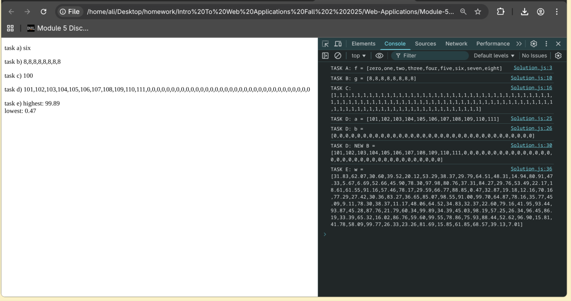

Chapter 10 Exercise 10.10
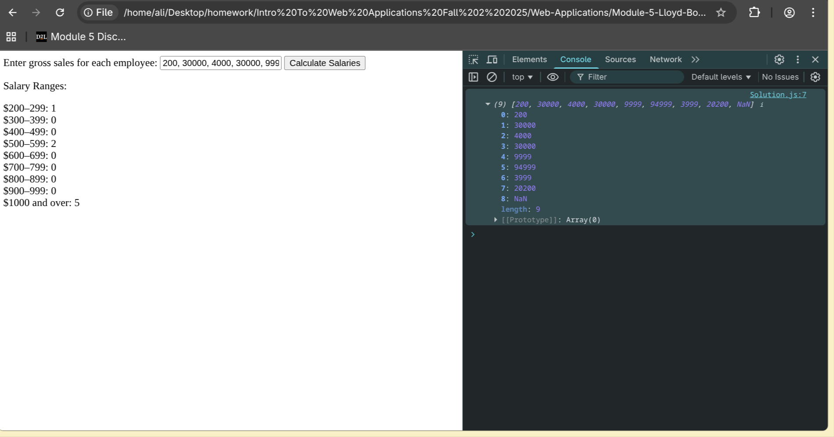

Chapter 11 Exercise 11.13
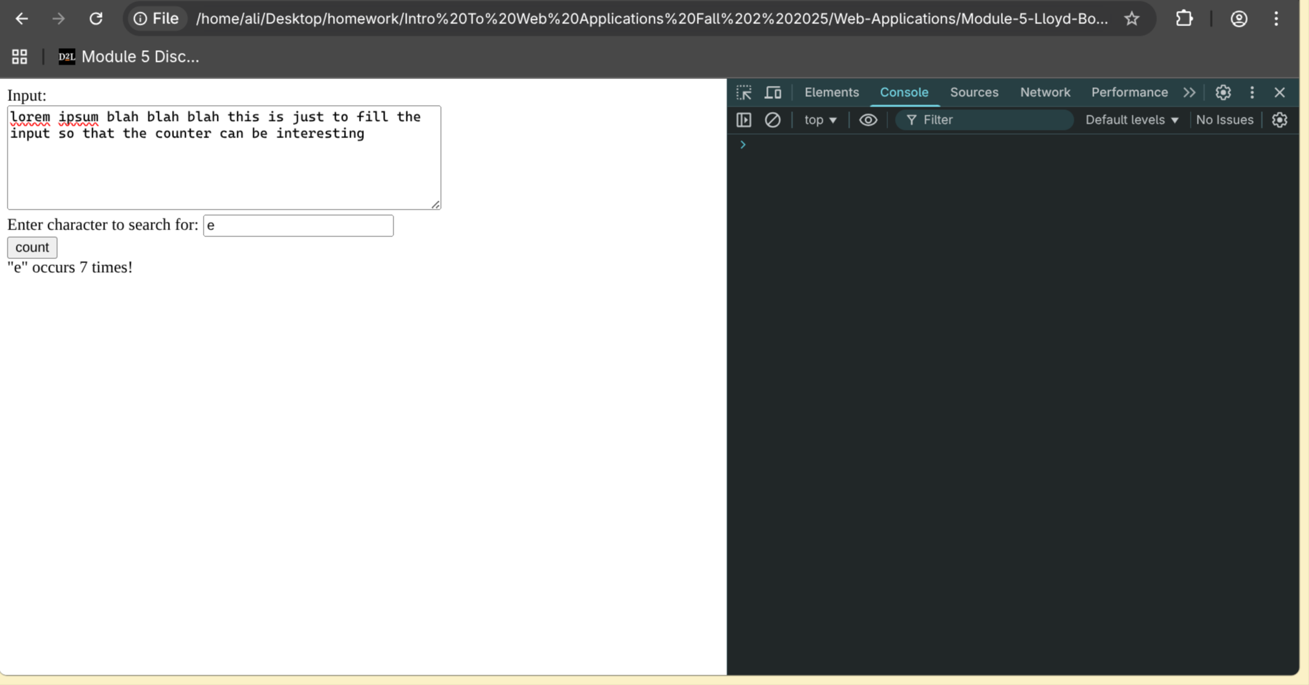

Chapter 11 Exercise 11.14
